MYSQL Assignment:

NOTE:

Please paste a screenshot of the query in the word document with query and output table for every question.

Question 1:

Create a database named “Product” and create tables inside it as shown below:

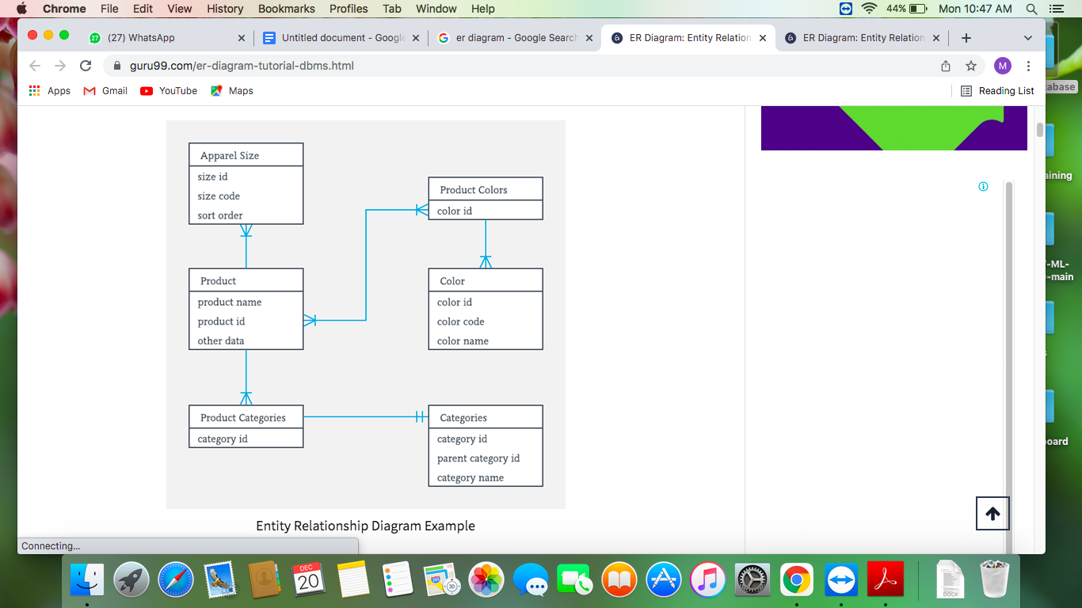

Keep in mind which table to create 1st and whom to make Primary key and Foreign key. Take a screenshot of every table which you create along with the description of the table.

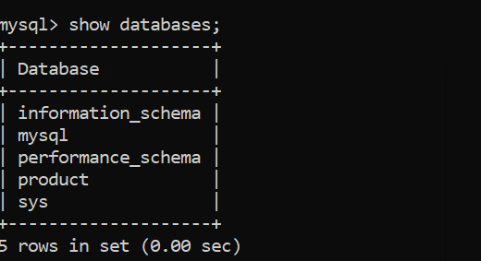

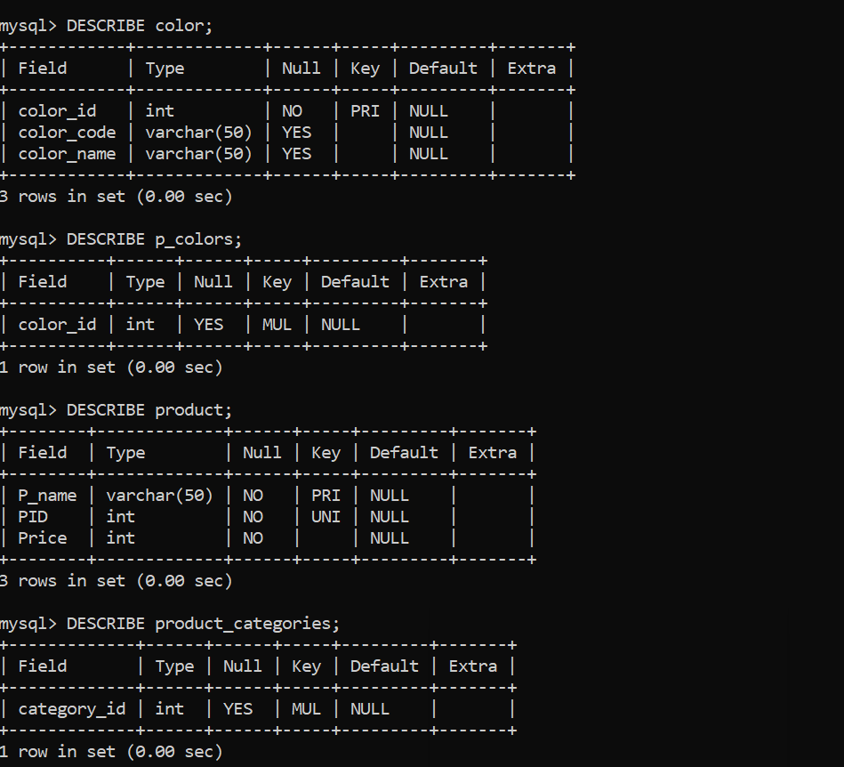

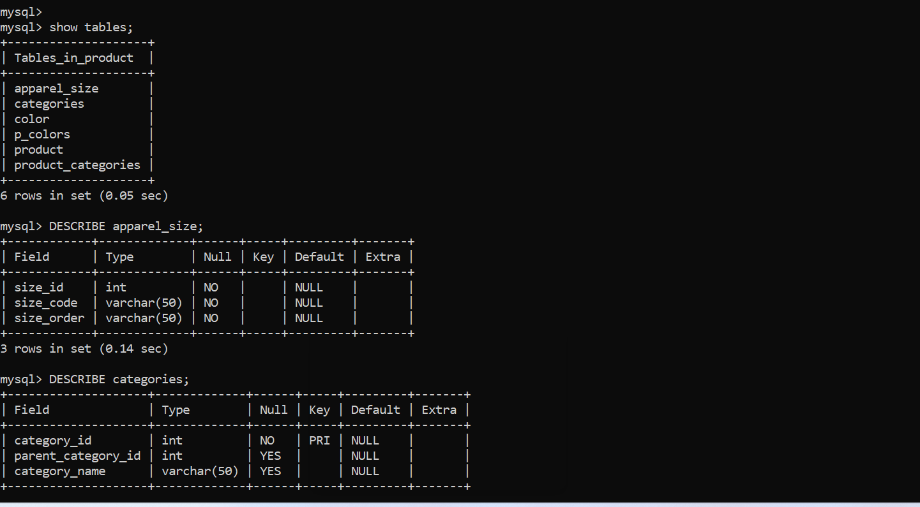

2. Insert 5 values in each table of your choice.(Keep in mind the foreign key referencing and also data types which you mention). Take a screenshot of every table after values get inserted along with the query.

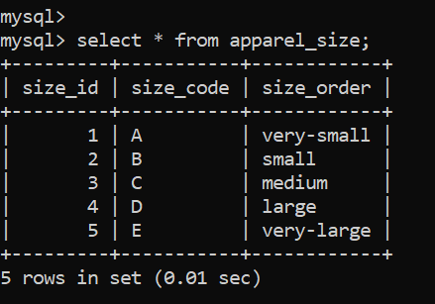

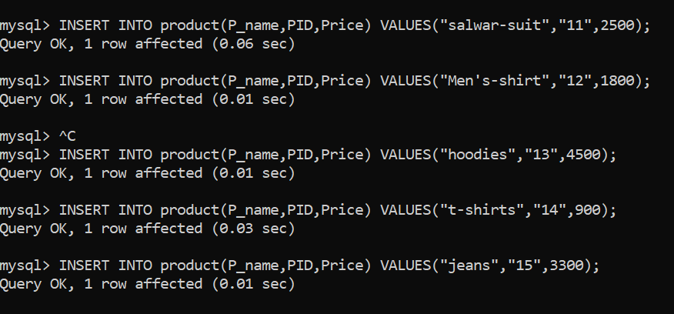

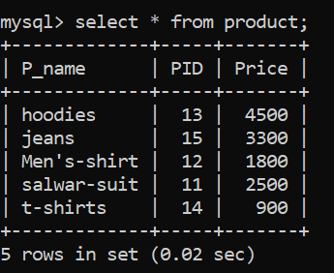

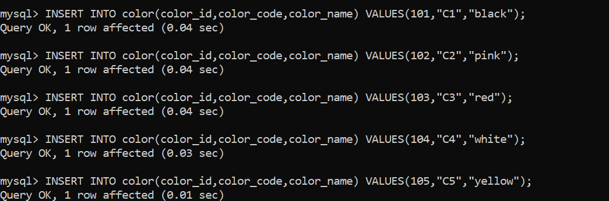

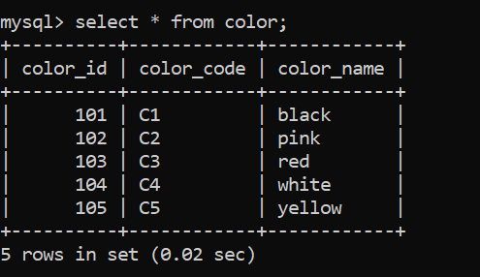

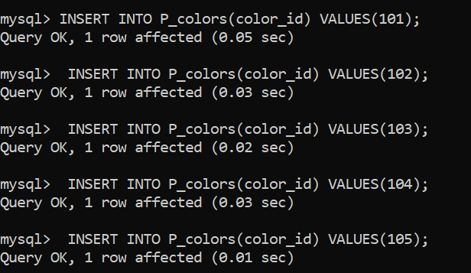

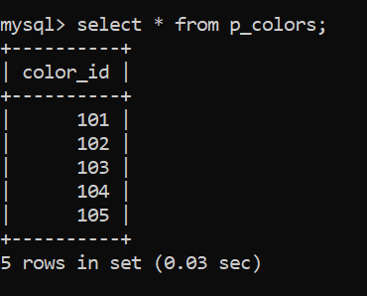

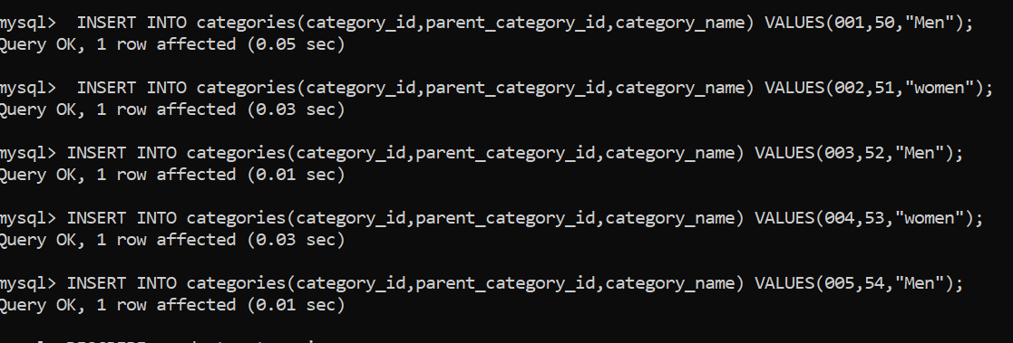

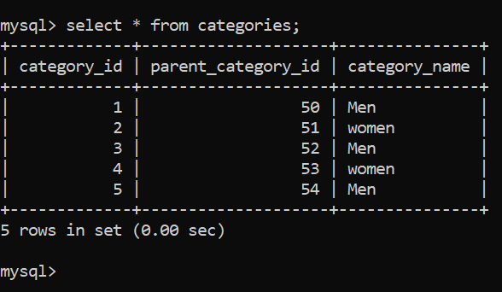

3.Some of the data entries in the table following parameters:

* Category ID should reply under (0-5) range.
* Product Name should be any of the following i.e. (Salwar suit, Men’s shirt, Hoodies,T-shirts, Jeans), each product category should be kept in mind while assigning the Product ID.
* In the categories table Category name should be only Men and women.

3. Write a query to print every table along with values and take a screenshot of the table and paste it in the word format.

4. Write a query to update the category table, change all the women category to unknown.

5. Write a query to match the name of all the products in the Products table where the name starts with “S”.

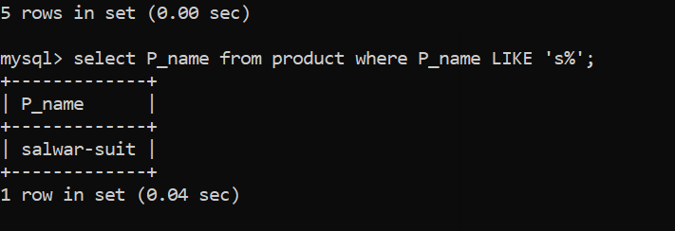

6. Write a query to print Color ID where color name is Black or Pink.

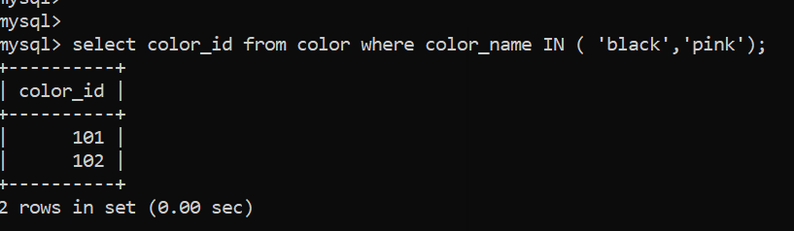

7. Alter table Categories add column “category description” in it also add some description in each record. HINT: it can be done with the help of the update command.

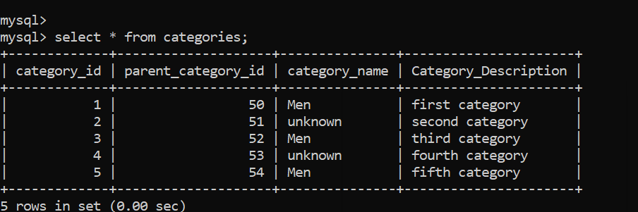

8. Write a Query to print all the columns of the table category where the category name is unknown.

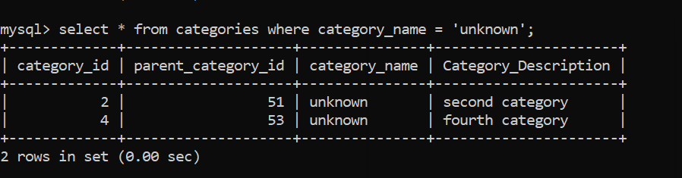

9.Create one table named “My wardrobe” with three columns naming clothes, color and price in the same database. Enter 5 entries of your choice and then find MIN,MAX,SUM,AVG,COUNT of the column “Price”.

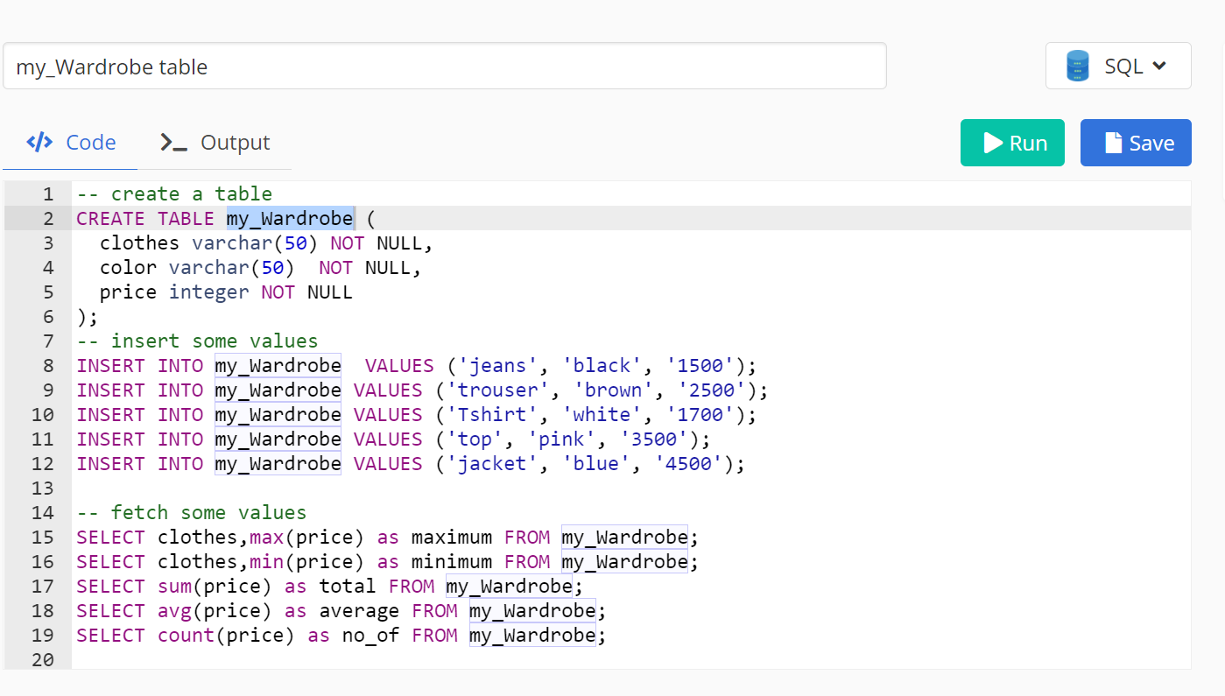

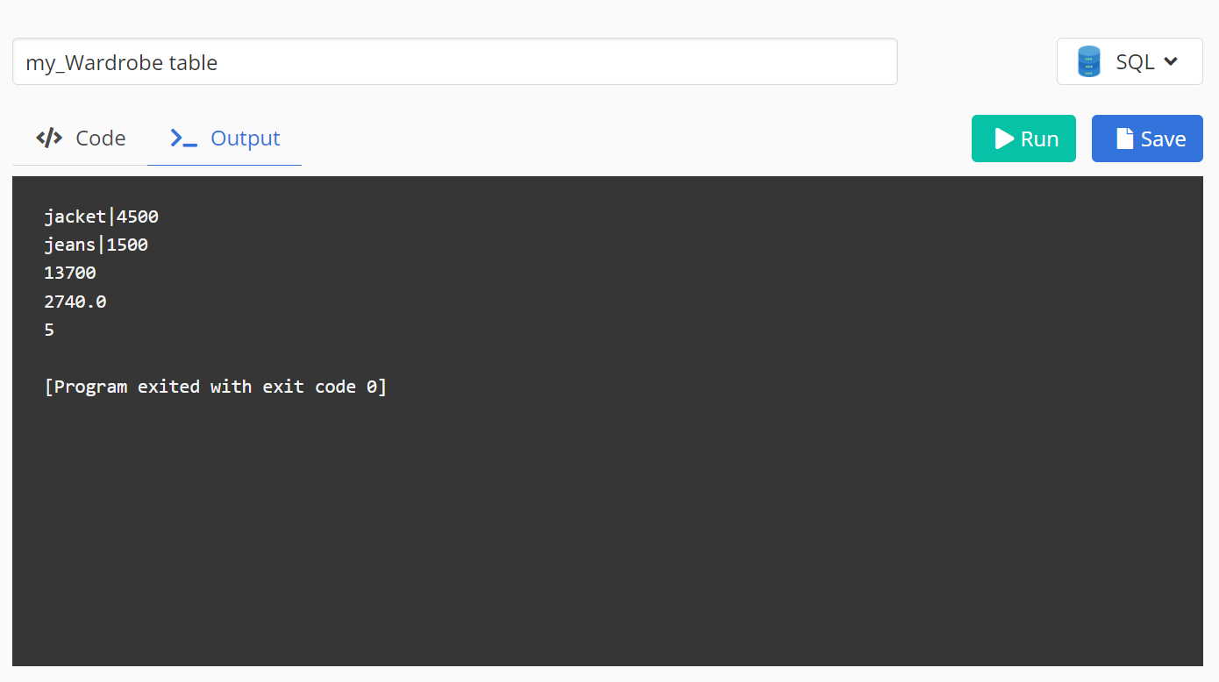

10. Delete the row having price greater than 2000 and print the table “My wardrobe”.

